EXPERIMENT 12
You are designing a Task Management System for a small team. The
system should include the following features:
1. User Login and Role Assignment
2. Task Creation and Assignment
3. Task Prioritization and Deadlines
4. Progress Tracking and Reporting
Prioritize these requirements using the MoSCoW and Kano models in
Jira.
Step 1:Open jira and select space and click on scrum
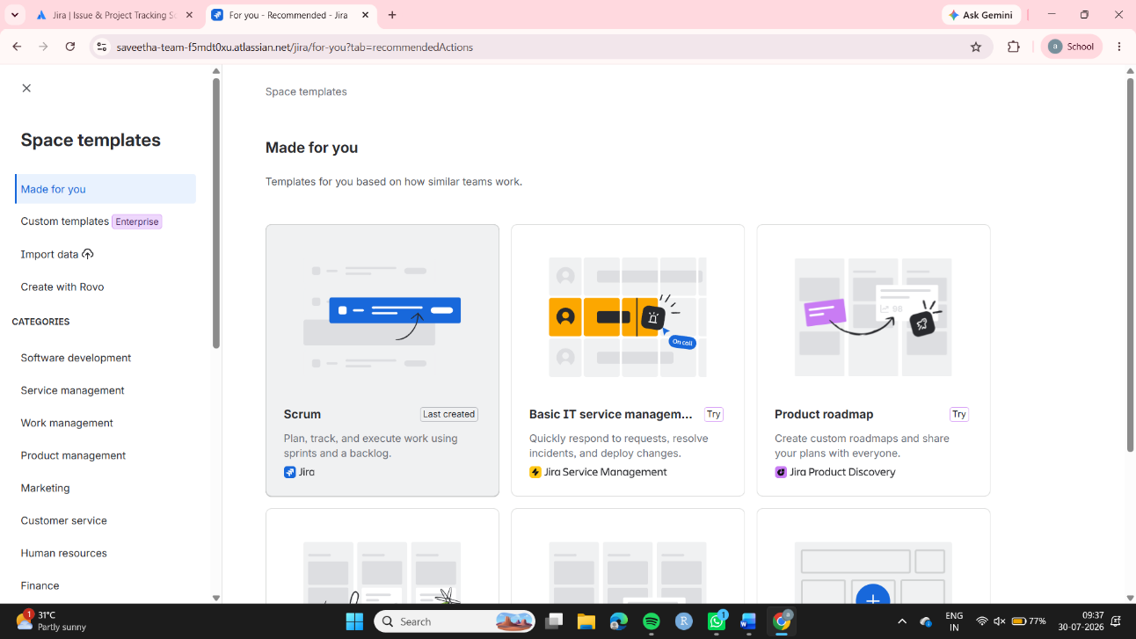

Step 2:In the homepage open settings and select Work items
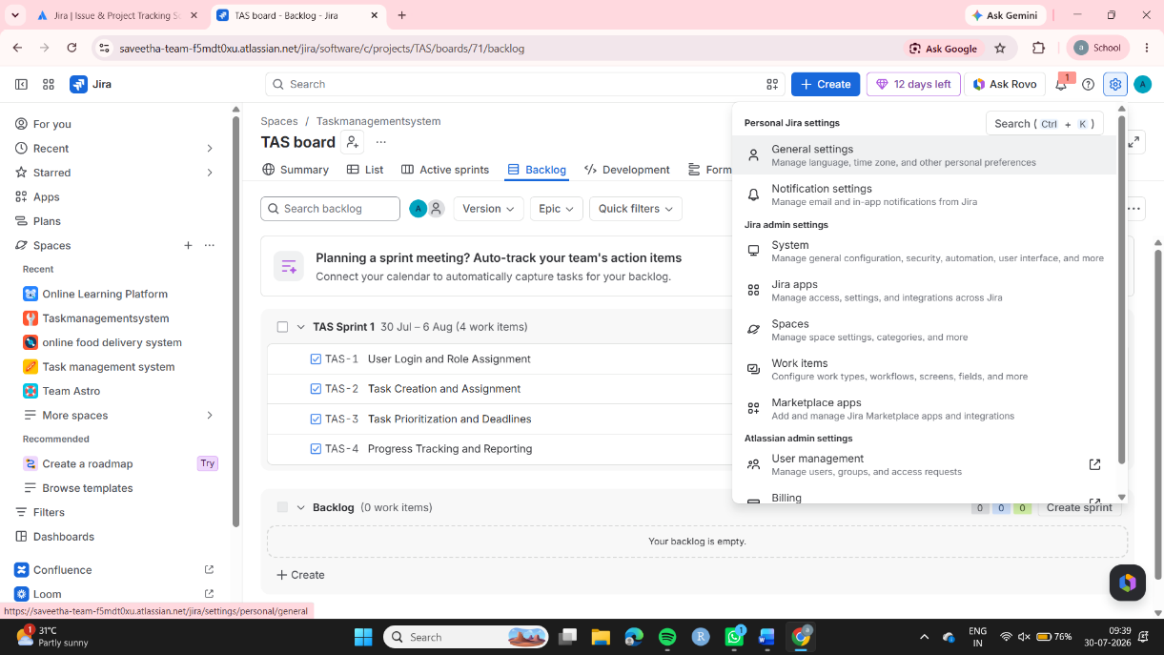

Step 4:Then click on the Priorities and change the priorites like this and check the priority schemes ,if they are updated move to home page
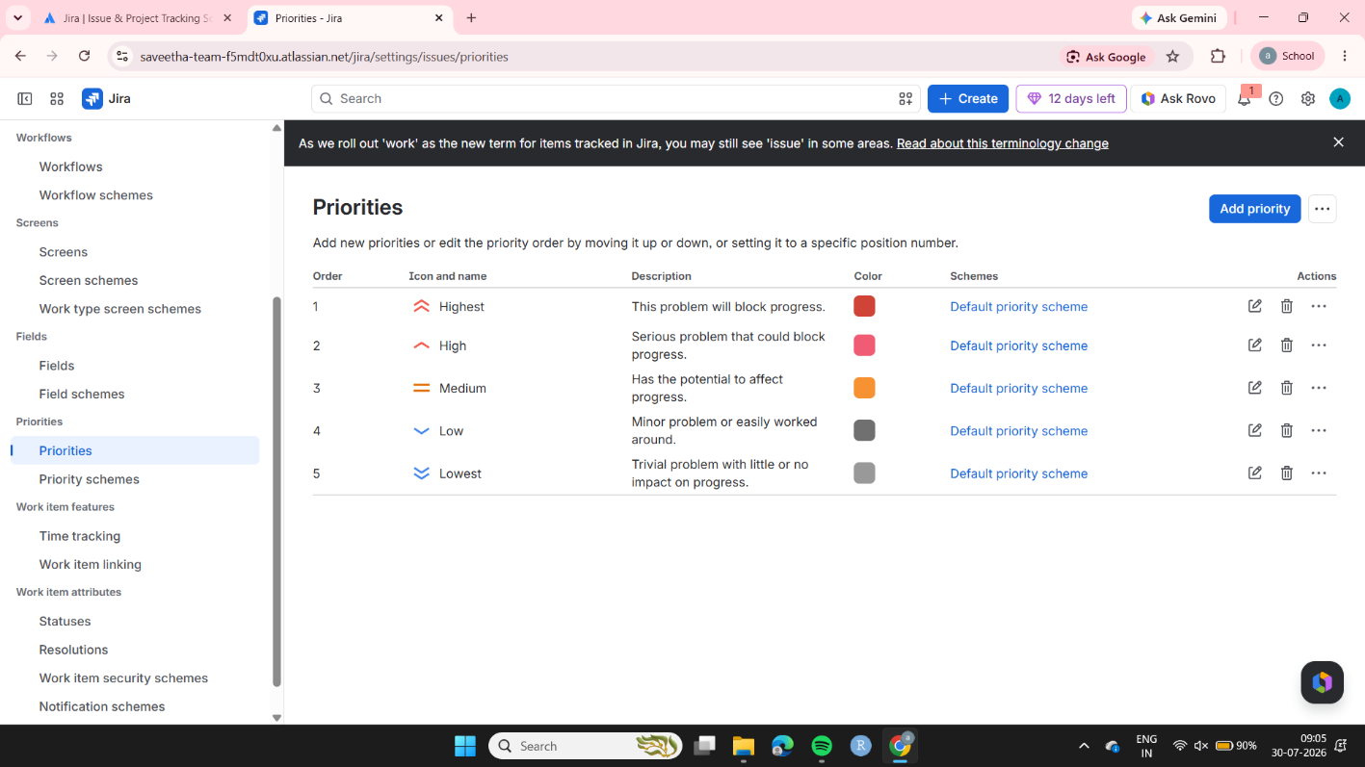

Step 5:Assign the tasks in the backlogs and assign the team members and change the priority and click on start sprint
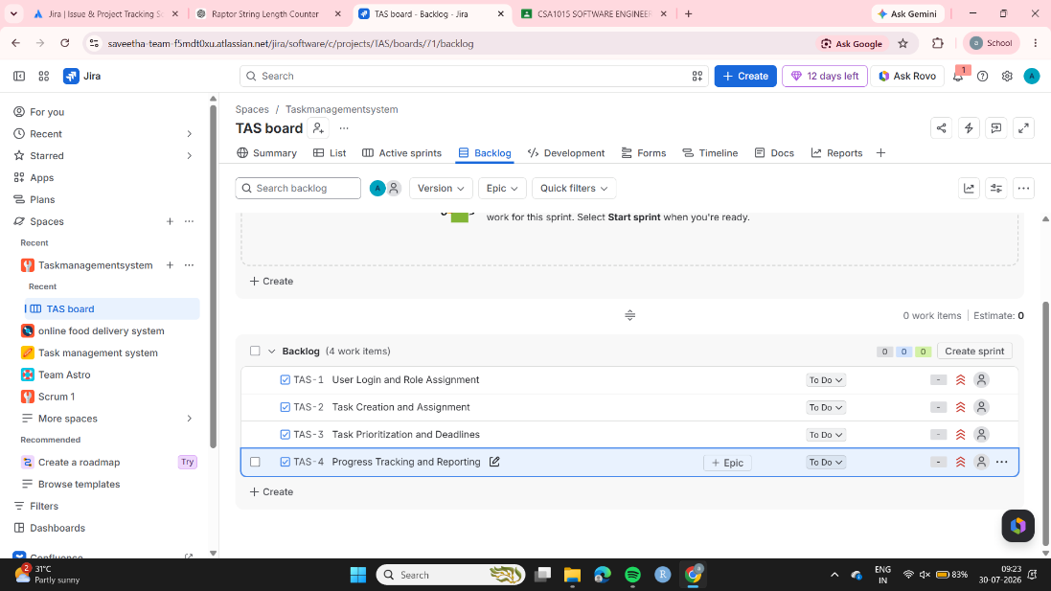

Step 6: Then all the tasks will be moved to TODO
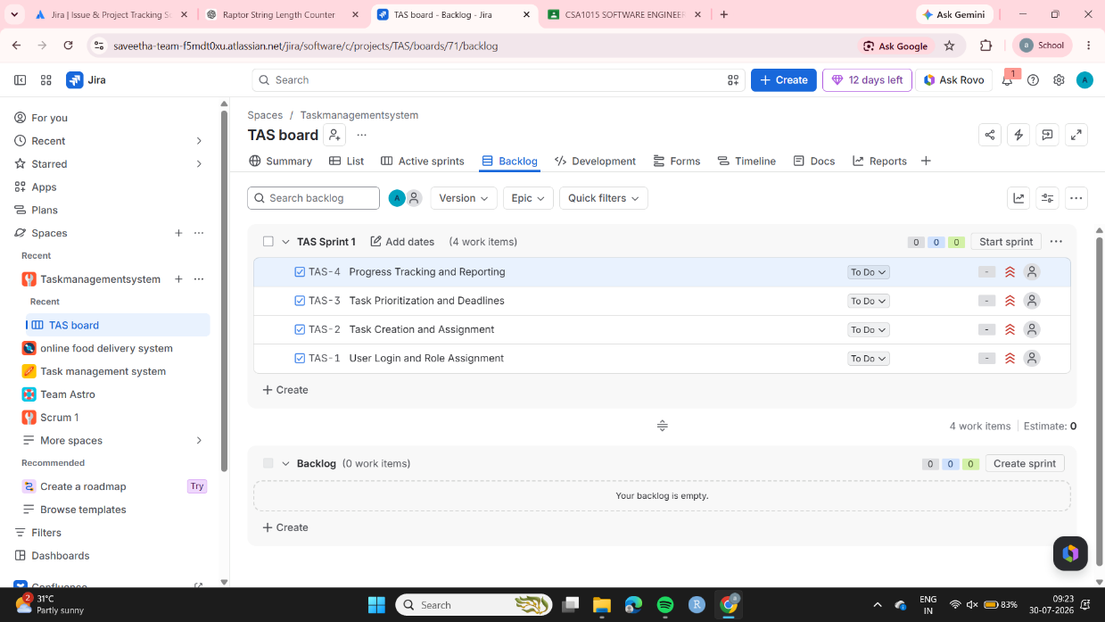

Step 7: Then move the tasks according to work done .
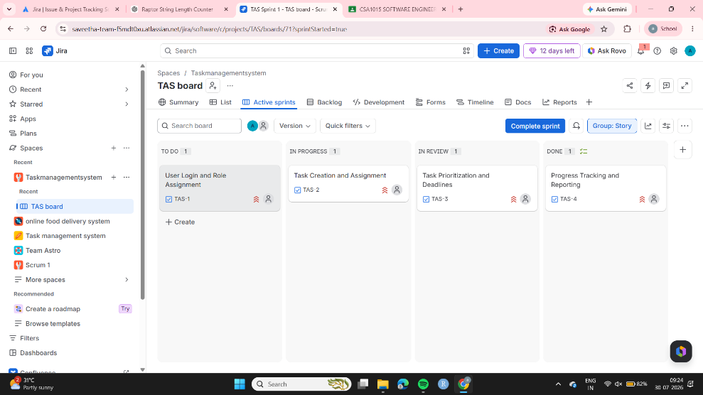

Step 8: Once all the tasks are finished move to LIVE
